# Optimizing Simultaneous Decisions

**Course Project**

**Instructions:**

In this project, you will work through an optimization problem that has increasing complexity.

*You will make three submissions in the course of completing this project. After completing Part One of the project, you will submit a partially completed version of this project document for instructor review. A submit button can be found on the Part One assignment page.*

*After completing each subsequent part of the project, resubmit this project document and any supporting documents to your instructor for grading. A submit button can be found on the Part Two and Part Three assignment pages. Information about the grading rubric is available on any of the course project assignment pages online.* *Do not hesitate to contact your instructor if you have any questions about the project.*

#### **Part One—Create a Linear Optimization Model**

In this part of the course project, you will create a mathematical model based on a specified goal and a set of predetermined market values.

In order to satisfy this part of the project, you will review the scenario and the parameters supplied in an Excel workbook. You will summarize the objective, list the decision variables, and identify constraints for the problem. In addition, you will formulate an Excel-based spreadsheet model. Finally, you’ll specify cells or cell ranges necessary to find an optimized solution using Solver.

Step 1: Begin by downloading the Excel workbook provided on the Course Project page. Find the sheet labeled “bid selection model” in the workbook.

**Scenario:** You are a confectionary manufacturer reviewing bids for the retail packaging you need for your products next quarter under a bid process. You have received one to five bids from each of six suppliers on 10 packaging products.

There are 18 bids in total, reflected in two tables in a supplied worksheet. The first table shows, for each bid, the maximum production commitment for each type of packaging. The second table shows the unit cost for each type of packaging.

In addition to these two tables, you have an array (a one-dimensional array) showing your minimum needs for each type of packaging. You will also see some cells that are shaded but have been left empty.

Step 2: Answer the following questions around this scenario:

1. What is the objective for this problem?

The objective of this problem is to identify the minimal cost for retail packaging based on different bids.

1. What are the decision variables for this problem?

$F$30:$W$39 is the decision variables. Minimum Units Needed for Each Product is the decision variable across all bids. Minimum Units Needed for Each Product count should be met across all bids in a optimized cost.

1. What constraint(s) is/are there in this problem? *(summarize this using words)*

The constraint what we have are the following:

* 1. Bids (Offered by Supplier) should be greater than or equal to Decision Variable Value
  2. UNIT COSTS (Specified by Suppliers as part of bid) should be minimal
  3. The sum of each Product(decision variable) should not exceed beyond Minimum units needed for each product.

Save a copy of this project document with your answers included. **You will need to provide this as part of your Project Part One submission.**

Step 3: Now complete a spreadsheet model of this problem in Excel. You will use the two matrices, the minimum needs array, and the blank, shaded cells to complete your model. Be sure to open the Solver dialog box and specify the objective, decision variables, and all constraints before saving the workbook.

*Hint:* You may wish to revisit the Excel model for the earlier activity: Find an Optimal Result Using Solver. This model uses the =SUMPRODUCT function, which is a function you need to use when calculating total costs in your model.

Step 4: **Submit the Excel workbook** with your completed model and this project document to your instructor using the Submit button on the Course Project, Part One assignment page.

**Part Two—Perform a Sensitivity Analysis**

In this part of the project, you will use Solver on the model you built in Part One to determine the optimal solution. Then you’ll perform a post-optimality analysis.

In order to satisfy this part of the project, **resubmit your Excel workbook with a Sensitivity Report** included. You will also need to **resubmit this project document** with answers to the following questions:

1. Objective: What is the optimal value you determined for your objective?

Optimal Value: 6800

1. Shadow prices: You’ve underestimated the need for Product 10 and need to increase your order by 3000 units. Using your current model and the resulting sensitivity report, how much will your costs increase as a result of this change?

Optimal Value will increase from 6800 to 7000. i.e. around 2000

1. Bid negotiation (reduced cost from supplier): A sales representative for supplier 1 has contacted you about your choice not to accept their Bid #6 for Product 5. The sales representative wants to know at what unit cost would he be able to earn your business.

If he reduces the cost by 0.3. We would start accepting his bid

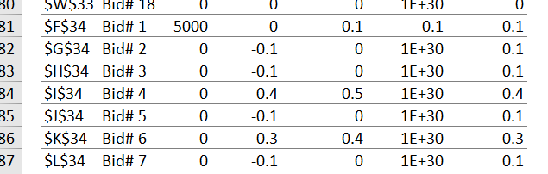

**Part Three—Model More Restrictive Decisions**

In this part of the project, you will refine your optimization model and re-examine post-optimality in response to an additional constraint.

Section A

New Scenario: Start with the scenario from Parts One and Two, but now suppose in the bid process the bids are all-or-nothing. You must either accept all products offered in a given bid or reject the bid entirely.

Step 1: Answer the following questions around this new scenario:

1. What is the objective for this problem?

The objective of this problem is to identify the minimal cost for retail packaging based on picking a bid for all products offered in a given bid by supplier.

1. What are the decision variables for this problem?

$F$40:$W$40 is the decision variables.Accept Bid which is a binary decision variable which will be used to decide which bid for all products offered in a given bid by supplier will be picked.

1. What constraints are there in this problem?

The constraints for the model is $F40:$W40 is binary.

The sum of each Product($Y$30:$Y$39) should not be less than Minimum units needed for each product 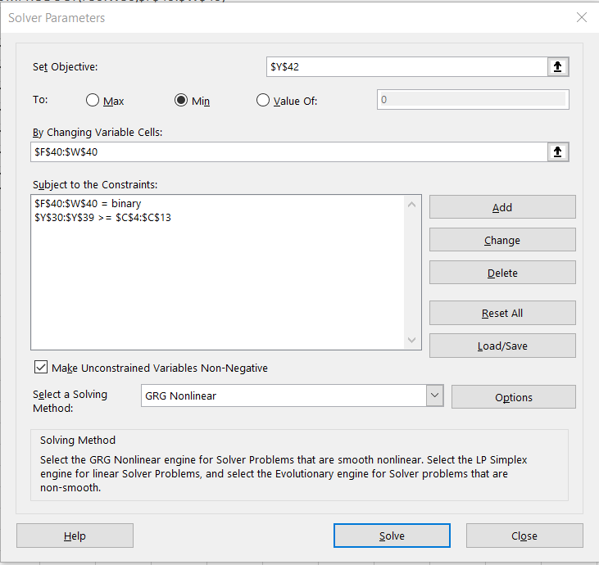

Step 2: Copy the model you built in Part One to a new sheet and label the new sheet “all-or-nothing bids.” In the new sheet, modify the model to create a revised model for this new scenario. Remember to make adjustments in the Solver dialog box as well. At a minimum, you will need to use unaltered versions of the bids table, unit costs table, and needs array. Other aspects of the model may need to change. Your answers to the questions above should guide your changes to the model.

Step 3: Run Solver on your new model, and save a copy of your revised workbook. **You will need to provide this for the Part Three submission.**

Step 4: Review the new Solver results and answer the following questions:

1. What, if any, are the negative business consequences under this new scenario?
   1. The Objective when we took optimized bid from each supplier was around 6800. Right now with all or nothing bid the optimized object raised from 6800 to 55000
   2. Also, we have to buy products, in our case Product 9 was not required but with this all or nothing bid we had to buy 9000 products.
2. How did your use of suppliers in the new scenario change from the original scenario in Part One?

Right now we are picking the suppliers in all or nothing mode. In the previous scenario we picked the supplier for each product based on the competency of pricing. Right now we are picking the supplier based on the pricing of their whole bid.

Section B

Additional constraint: Within your all-or-nothing bid scenario, consider the impact on your model if management has set a requirement that you meet your product packaging needs by accepting bids from at least three of the six suppliers. For this section you will not be asked to adjust your model, but answer the following question:

1. What do you see as the main challenge(s) in adjusting in your model based on management’s requirement?

I have to modify the model by adding 1 more constraint which would limit the count or sum of Decision variable ($F$40:$W$40) to 3. But, when I tried that test my model was not resolving and it was all getting back with 4 suppliers.

Step 5: **Submit the Excel workbook** with your completed model and this project document to your instructor using the Submit button on the Course Project, Part Three assignment page.